# CHAPTER 5

**DISCUSSION, CONCLUSION AND RECOMMENDATIONS**

# 5.1 SUMMARY OF FINDINGS

This chapter describes the objectives of the system stipulated in earlier chapters, limitations of the system, conclusion and recommendation of the system.

# The main goal of this study was to develop a desktop application that could assist ESCHOSYS TECHNOLOGIES in getting it’s trainees attendance and how the trainees can give their feedback on teachers and methods used to teach. To complete this project, we began by outlining the issue, outlining our suggested fix, and laying out our goals. By meeting our objectives, which largely involved creating a desktop application for student attendance and teacher feedback, we have completed the project.

# 5.2 DIFFICULTIES ENCOUNTERED

A lot of challenges surfaced during the development of this application. The following are some of the problems or challenges encountered:

* **Difficulties Related to Design of the platform**

The design of such an application involves the knowledge of many programming and procedural languages such as knowledge on HTML, CSS, PHP, JavaScript etc. This implied learning more and mastering them in order to construct a good application that answers the user’s needs.

* Understanding the MySQL Database Syntax.

# 5.3 CONCLUSION

The end of this work marks the beginning of many achievements which have been accomplished according to the objectives formulated. Firstly, this platform has been designed using the 3-tier architecture, which consist of a client, server and the database all interacting with each other through JavaScript language at the level of the control. The development of a school attendance/feedback system brings numerous advantages, including increased efficiency, improved accuracy, standardized documentation, and improved users satisfaction.

Implementing this platform was challenging as it requires the knowledge of many programming languages to make it function to meet the standard needs.

# 5.4 RECOMMENDATIONS

This system which is a school attendance/feedback system is there to replace the manual way of taking students attendance and how students give feedbacks. This system is there to reduce or minimize errors and provide an efficient and reliable means of getting attendance and feeds. So, training centres, schools and internship locations still adopting manual attendance and student feedback with risks of having inaccurate attendance records and feedbacks should use this system.

# REFERENCES

1. Patel UA, Swaminarayan Priya R. Development of a student attendance management system using RFID and face recognition: a review. Int J Adv Res Comput Sci Manag Stud. 2014;2(8):109–19.
2. Jacksi K. Design and Implementation of Online Submission And Peer Review System: A Case Study Of E-Journal Of University Of Zakho. Int J Sci Technol Res. 2015;4(8):83–5.
3. Jacksi K, Badiozamany S. General method for data indexing using clustering methods. Int J Sci Eng. 2015 Mar;6(3):641–4
4. Karl J. Åström and Richard M. Murray. On [Feedback Systems](https://www.bing.com/ck/a?!&&p=ca9c3de67946185bfc41ac62bc349a9bff557a23b6825ce013ab61f13836aa0eJmltdHM9MTc0MDYxNDQwMA&ptn=3&ver=2&hsh=4&fclid=34ec8b4d-69d8-6bf4-0752-9ec568616a15&u=a1aHR0cHM6Ly9mYnN3aWtpLm9yZy93aWtpL2luZGV4LnBocC9GZWVkYmFja19TeXN0ZW1zOl9Bbl9JbnRyb2R1Y3Rpb25fZm9yX1NjaWVudGlzdHNfYW5kX0VuZ2luZWVycw&ntb=1) (Book)
5. Miller, T., & Green, E. (2021). "Designing Effective Anonymous Feedback Systems." Human-Computer Interaction.
6. O'Connell, R., & Diaz, C. (2020). "The Role of Anonymity in Online Feedback." Computers in Human Behaviour.
7. Taylor, P., & White, J. (2023). "Student Feedback Systems: A Review of the Literature." Educational Psychology Review.

**Book References**

1. Stone, D. (2014). Thanks for the Feedback: The Science and Art of Receiving Feedback Well. Viking.
2. Grant, A. M. (2013). Give and Take: Why Helping Others Drives Our Success. Viking.
3. Allen, D. G. (2017). Employee Retention: A Practical Guide. Society for Human Resource Management.
4. Cascio, W. F., & Aguinis, H. (2019). Applied Psychology in Human Resource Management. Pearson.
5. Noe, R. A., Hollenbeck, J. R., Gerhart, B., & Wright, P. M. (2020). Human Resource Management: Gaining a Competitive Advantage. McGraw-Hill Education.

**APPENDIX**

**Homepage**

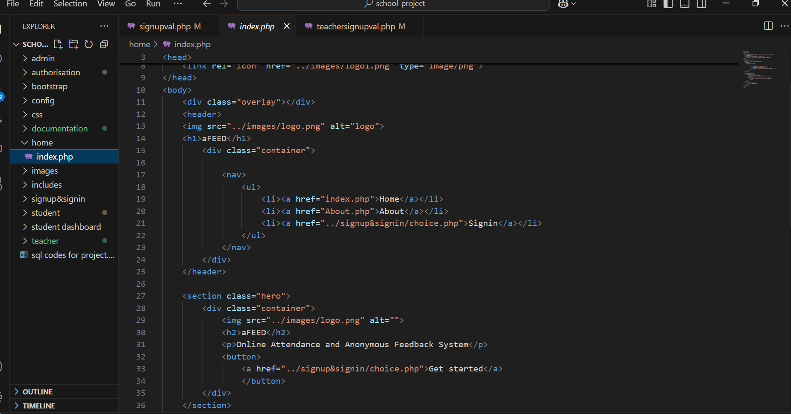

**Login page**

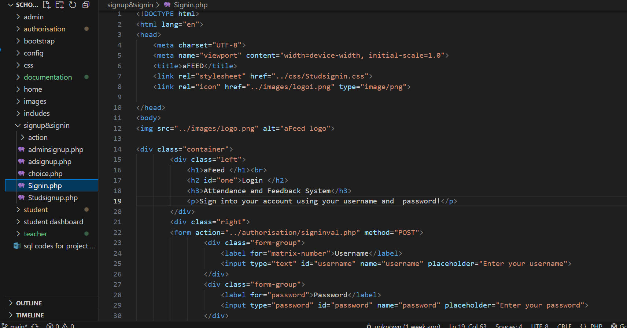

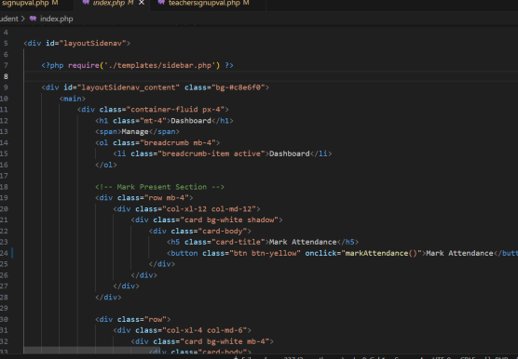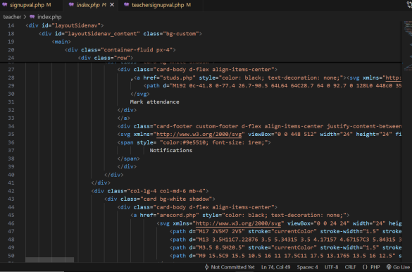**Dashboards**